ASSIGNMENT-09

Date:30-05-2025

Batch no-1

25VID1334-DWS

Steps for creating a package using MSIX packaging Tool

**Steps:**

1. Download **MSIX Packaging Tool** from Microsoft Store
2. 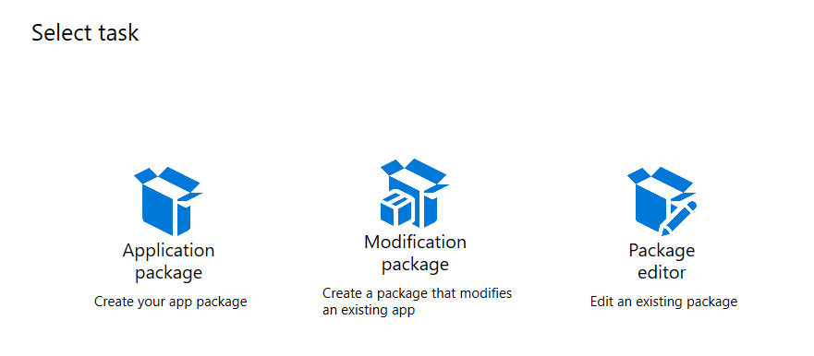Open MSIX Packaging Tool and in **Select Task** select **Application Package**
3. In **Select environment** tab, select first radio button **Create package on this computer** and click **Next**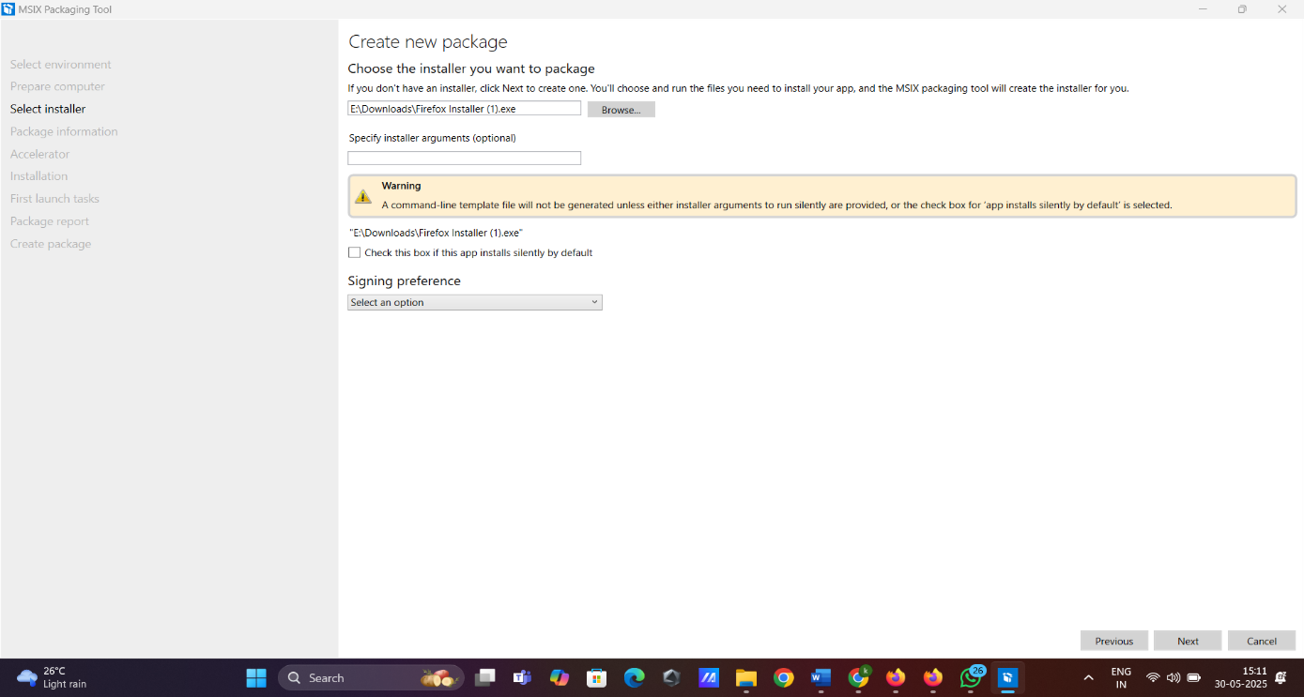
4. In **Prepare computer** tab, after the status shows **Installed**, at the bottom click on checkbox **Windows Search is active** and click **Next**

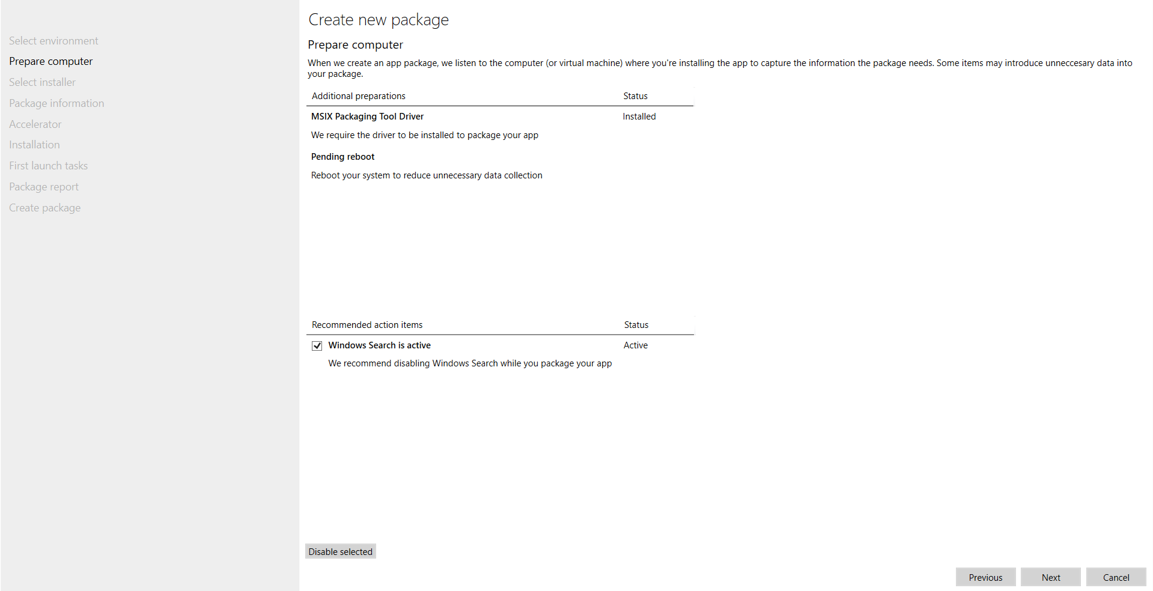

1. In **Select installer** tab, browse our **.msi file (Firefox Setup 139.0.1.msi)** and in **Signing preference** dropdown select **Do not sign package** and click **Next**
2. 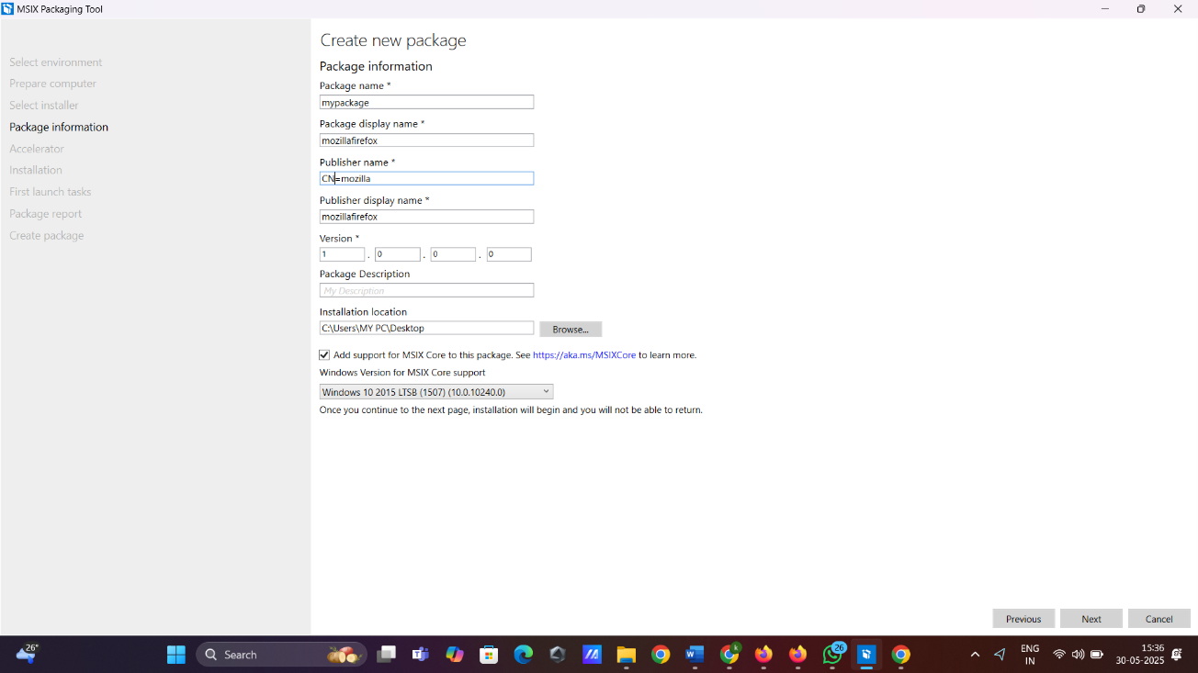In **Package information** tab, in the **Publisher name** textbox write **CN=Mozilla** and click on checkbox **Add support for MSIX Core to this package** and in dropdown select **Windows 10 2016 LTSB (1607) (10.0.14393.0)** and click **Next**
3. In **Accelerator** tab, do nothing and click **Next**

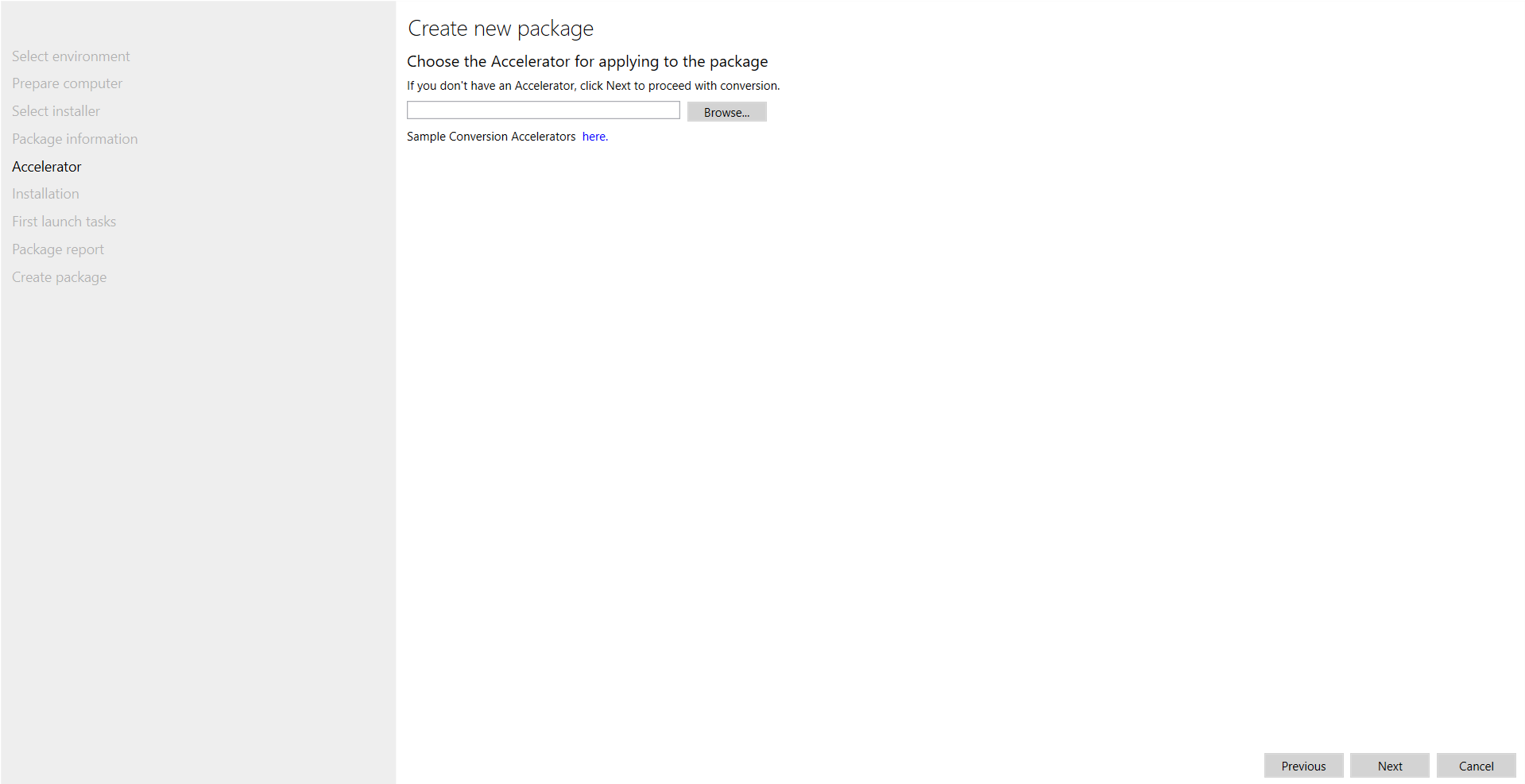

1. In **Installation** tab, do nothing and click **Next**

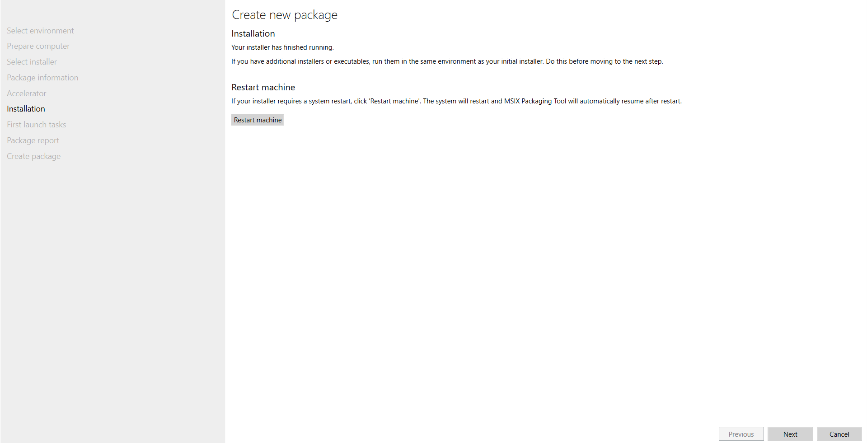

1. In **First launch tasks** tab, do nothing and click **Next** and then a small popup comes asking **Are you done?** so click **Yes, move on** butto

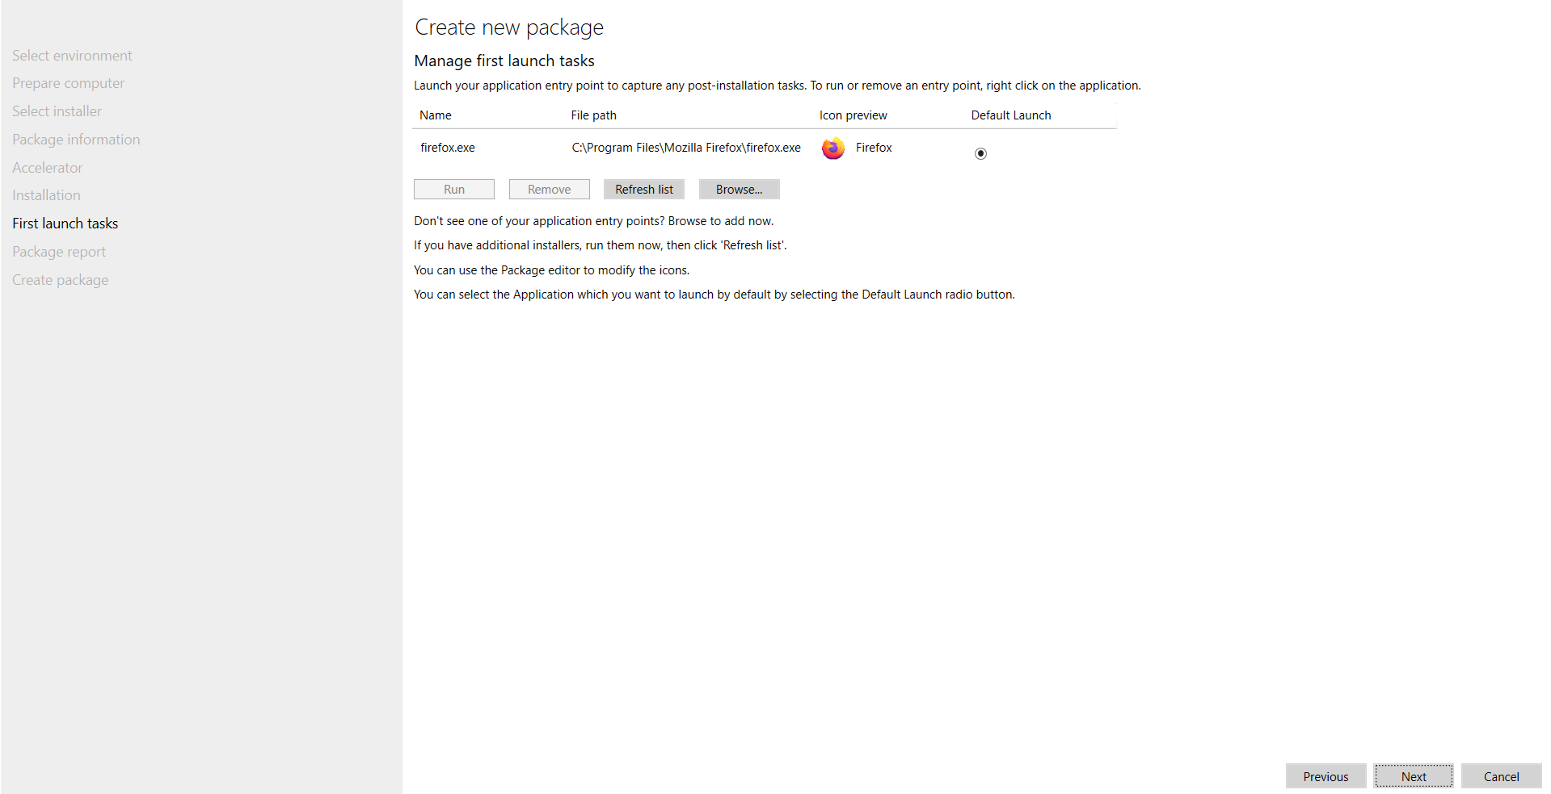

1. in Package report lab, do nothing and click next.

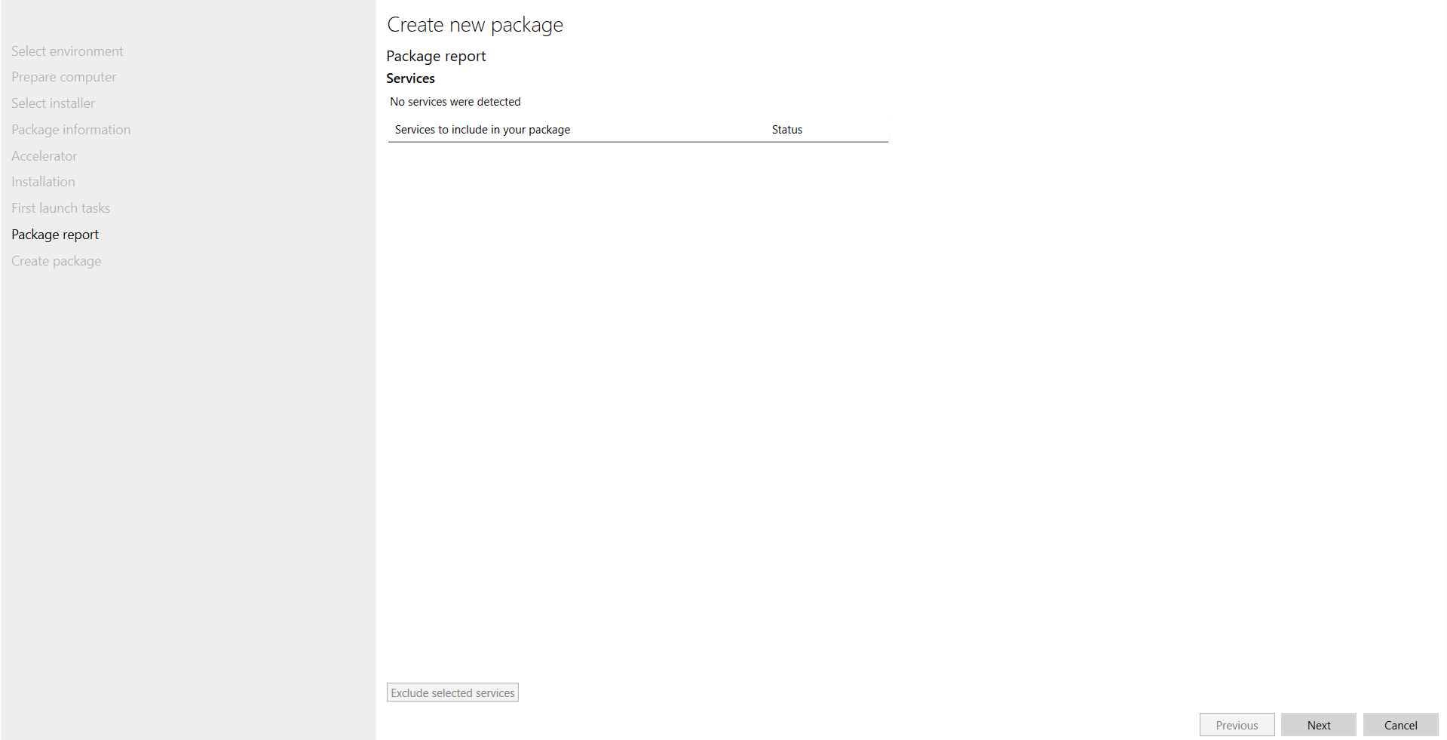

11)In create package tab, browse the path where we want our package and files to be placed after getting created and click create and them a small popup comes package successfully created so click close button

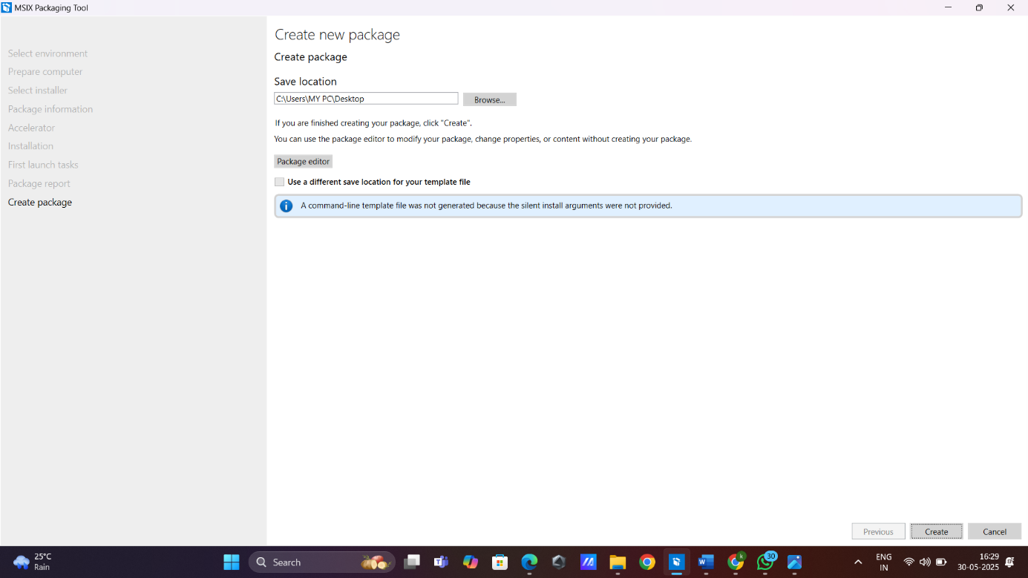

1. Open file explorer and check for .msix and .xmi files in ourpreferred directory

